Luxury Living At Its Best
Ambrose
2901 INDIANA St. DALLAS, TX. 75226
P:214-573-2552 F:214-573-2552
WWW.BROADSTONEAMBROSE.COM
Colorful Design Directions
-Open and spacious floor plans maximizing natural light
-Expansive 10-foot ceilings and 8-foot entry doors
Washers and dryers in every unit
-Two-toned paint scheme with custom color accent walls
-Wood laminate or stained concrete flooring in entries, living and dining areas
-Computer desks with granite counter tops*
-2-inch mini blinds
-Digital thermostat
-Private balcony or patio*

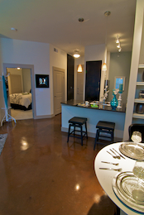

The Green Scene

-Internet Café
-Fully equipped athletic center with cardio theater, free weights and individual weight machine
-Sparkling swimming pool with sunning ledge
-Outdoor grills for entertaining
-Multi-level parking garage with remote-controlled access

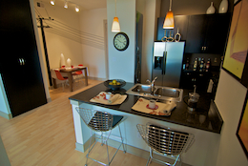

Offering a $500 look and Lease special
ASK ABOUT OUR Preferred Employer discounts!

